**AIM OF THE EXPERIMENT**: AUTOMATION OF TURN OFF MECHANISM OF RUNNING TAP

**TITLE OF THE EXPERIMENT:** DESIGN AND IMPLEMEMTATION OF AN AUTOMATIC TAP STOPPER

**INTRODUCTION:-**

About 71% of earth is covered with water, but sadly only 2.5% of it is drinking water. With rise in population, pollution and climate change, it is expected that by as soon as 2025 we will experience perennial water shortages. At one hand there are already minor disputes among nations and states for sharing river water on the other hand we as humans waste a lot of drinking water due to our negligence.

It might not appear big at the first time, but if your tap dripped a drop of water once every second it would take only about five hours for you to waste one gallon of water, that is enough water for an average human to survive for two days. So what can be done to stop this? As always the answer, for this, lies with improvement in technology. If we replace all the manual taps with a smart one that opens and closes on its own automatically not only we can save water but also have a healthier lifestyle since we don’t have to operate the tap with our dirty hands.

**MATERIALS REQUIRED**

|  |  |
| --- | --- |
| **Materials Used** | **Quantity** |
| Arduino Uno | 1 |
| Power Adapter | 1 |
| Servo Motor | 1 |
| HCSR04 Ultrasonic proximity Sensor | 1 |
| Breadboard | 1 |
| Photo transistor | 5 |
| 470Ω resistor | 10 |
| Keg | 1 |
| Male jumper wire | 30 |
| Female jumper wire | 10 |
| Pipes | 1 |
| Battery | 1 |
| Plumbing glue | 1 |
| Other plumbing items |  |

**THEORY BEHIND THE EXPERIMENT**

**Brief description and working principles of components used in the project**

**ARDUINO UNO**

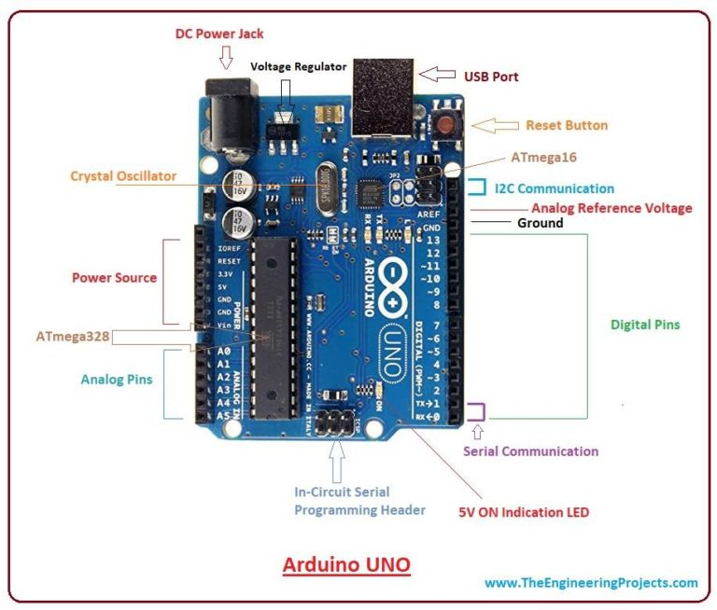

Arduino Uno is a microcontroller board developed by Arduino.cc which is an open-source electronics platform mainly based on AVR microcontroller Atmega328.

The current version of Arduino Uno comes with USB interface, 6 analog input pins, 14 I/O digital ports that are used to connect with external electronic circuits. Out of 14 I/O ports, 6 pins can be used for PWM output. It allows the designers to control and sense the external electronic devices in the real world.

This board comes with all the features required to run the controller and can be directly connected to the computer through USB cable that is used to transfer the code to the controller using IDE (Integrated Development Environment) software, mainly developed to program Arduino. IDE is equally compatible with Windows, MAC or Linux Systems, however, Windows is preferable to use. Programming languages like C and C++ are used in IDE. There are many versions of Uno boards available, however, Arduino Nano V3 and Arduino Uno are the most official versions that come with Atmega328 8-bit AVR Atmel microcontroller where RAM memory is 32KB.

Arduino Uno comes with USB interface i.e. USB port is added on the board to develop serial communication with the computer.

Atmega328 microcontroller is placed on the board that comes with a number of features like timers, counters, interrupts, PWM, CPU, I/O pins and based on a 16MHz clock that helps in producing more frequency and number of instructions per cycle.

**SERVO MOTOR**

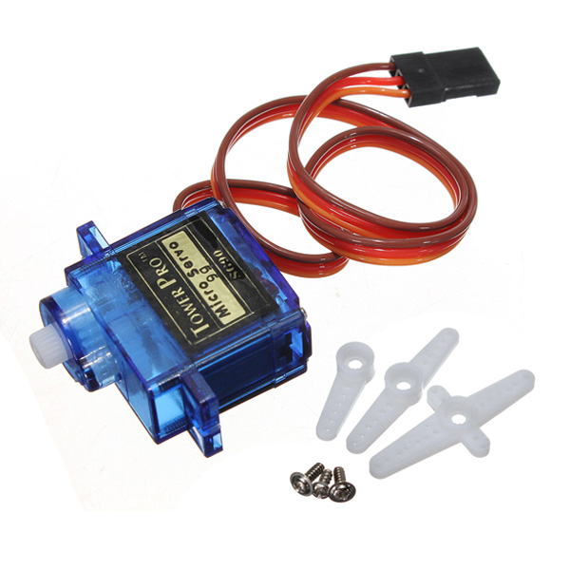

A servo motor is a rotary actuator or a motor that allows for a precise control in terms of the angular position, acceleration, and velocity. Basically it has certain capabilities that a regular motor does not have. Consequently it makes use of a regular motor and pairs it with a sensor for position feedback .

**PRINCIPLE OF OPERATION**

Basically a servo motor is a closed-loop servomechanism that uses position feedback to control its motion and final position. Moreover the input to its control is a signal ( either analogue or digital ) representing the position commanded for the output shaft .

The motor is incorporates some type of encoder to provide position and speed feedback. In the simplest case, we measure only the position. Then the measured position of the output is compared with the command position, the external input to controller. Now If the output position differs from that of the expected output, an error signal generates. Which then causes the motor to rotate in either direction, as per need to bring the output shaft to the appropriate position. As the position approaches, the error signal reduces to zero. Finally the motor stops..

Servomotors also find uses in optical rotary encoders to measure the speed of output shaft and a variable-speed drive to control the motor speed. Now this, when combined with a PID control algorithm further allows the servomotor to be in its command position more quickly and more precisely with less overshooting .

**POWER ADAPTERS**

It is also referred to as a power supply or power adaptor, an AC adaptor plugs into a standard electrical outlet and converts the AC electrical current from the wall outlet to the specifications needed by the electrical device that's plugged in. The AC adaptor is a box attached to the power cord, either at the end of the cord where the device plugs into the wall outlet, or in the middle of the power cord.

**PRINCIPLE OF OPERATION**

In short, a power adaptor converts the electric currents received by the electrical outlet into a typically lower alternating current that an electronic device can use.

Inside the power adaptor are two wire windings that wrap around a single iron core. The first of the windings receives the 120-volt alternating current delivered to the electrical outlet, and creates an electric field in the iron core. The second wire winding turns the newly created electric field into a smaller alternating electric current. The measure of the resulting alternating current is dependent upon the number of coils in the second wire winding in relation to the number in the first winding. If the second winding is half of the first winding, the alternating current will measure half of what it did when it entered the power adaptor. Therefore, if there were 100 coils on the first winding, the second winding will have only 50 coils.

**BREAD BOARD**

A breadboard is a simple device designed to let you create circuits without the need for soldering. They come in various sizes, and the design can vary.

**PRINCIPLE OF OPERATION**

The two larger pieces of wire down each side are typically used to connect a power source to the board. They are usually referred to as power rails. The other smaller pieces of wire running perpendicular all the way across the board are used for components in your circuit.

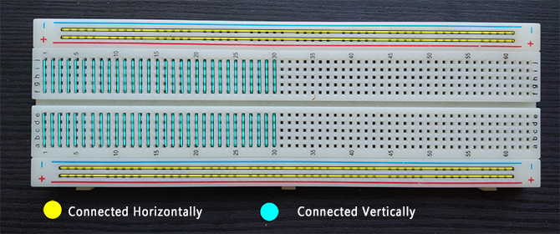

The power rails run horizontally as two rows at the top and bottom. Meanwhile, the vertical columns run inwards as you move down the board.If you were to pull any one of these metal pieces out, you would see their purpose. They’re designed to grab onto the legs of any components pushed through the breadboard holes. This allows you to test circuits without having to worry about soldering, or making a good contact with the board.

**HCSR04 ULTRASONIC SENSOR**

The ultrasonic sensor works on the principle of SONAR and RADAR system which is used to determine the distance to an object. An ultrasonic sensor generates the high-frequency sound (ultrasound) waves. When this ultrasound hits the object, it reflects as echo which is sensed by the receiver

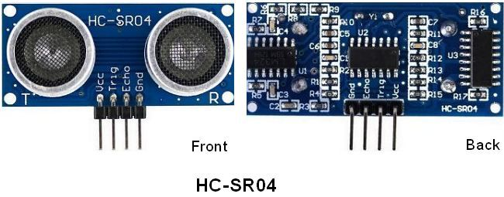

**PRINCIPLE OF OPERATION**

By measuring the time required for the echo to reach to the receiver, we can calculate the distance. This is the basic working principle of Ultrasonic module to measure distance.

ultrasonic module HCSR04, we have to give trigger pulse, so that it will generate ultrasound of frequency 40 kHz. After generating ultrasound i.e. 8 pulses of 40 kHz, it makes echo pin high. Echo pin remains high until it does not get the echo sound back. So the width of echo pin will be the time for sound to travel to the object and return back. Once we get the time we can calculate distance, as we know the speed of sound.

HC-SR04 can measure up to range from 2 cm - 400 cm.

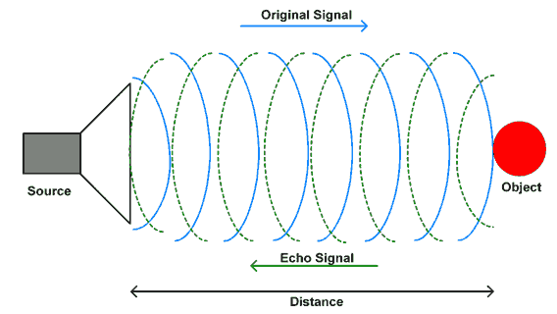

**WORKING PRINCIPLE OF AN AUTOMATIC TAP STOPPER**

The set-up is shown below.

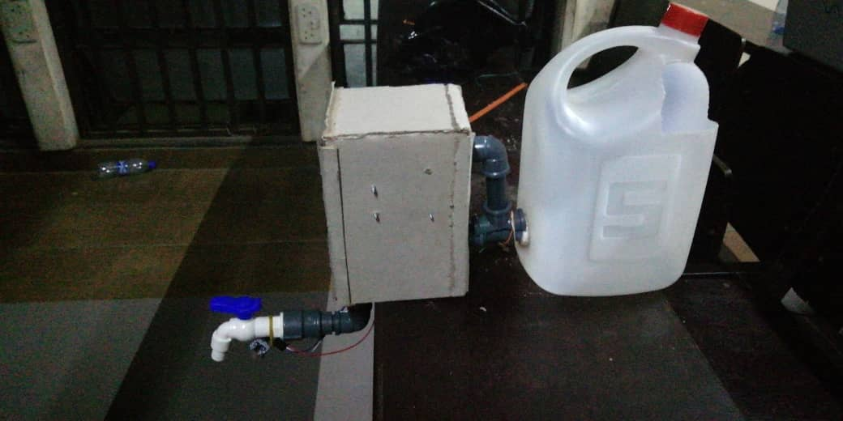d

The Arduino uno is a Development board which operates with 12V

The Ultrasonic Sensor is powered by the +12V power adapter and ground pins of the Arduino. The Echo and Trigger pin is connected to the pin 8 and pin 9 respectively. We can then program the Arduino to use the Ultrasonic sensor to measure the distance and turn on the photo transistorwhen an object is detect. The whole circuit is simple and hence can be easily build on top of a breadboard. Mine looked something like this below after making the connections.

The ultrasonic proximity sensor connected to the arduino uno .the proximity sensor sends an input to the arduino unono sends an output to the servo motor.

Whenever it detects someone placing hand beneath the tap, it commands the servo motor to turn-on the tap and keep a check on. When the user removes the hand, the tap would be turned off instantly. This would ensure that tap runs only when needed, conserving the precious water.

,